Assignment 6 (Part 2)

Prashanna Acharya
Algorithms and Data Structures (MSCS-532-M80)
University of the Cumberlands

GitHub Link: https://github.com/prashcodes10

Implementation
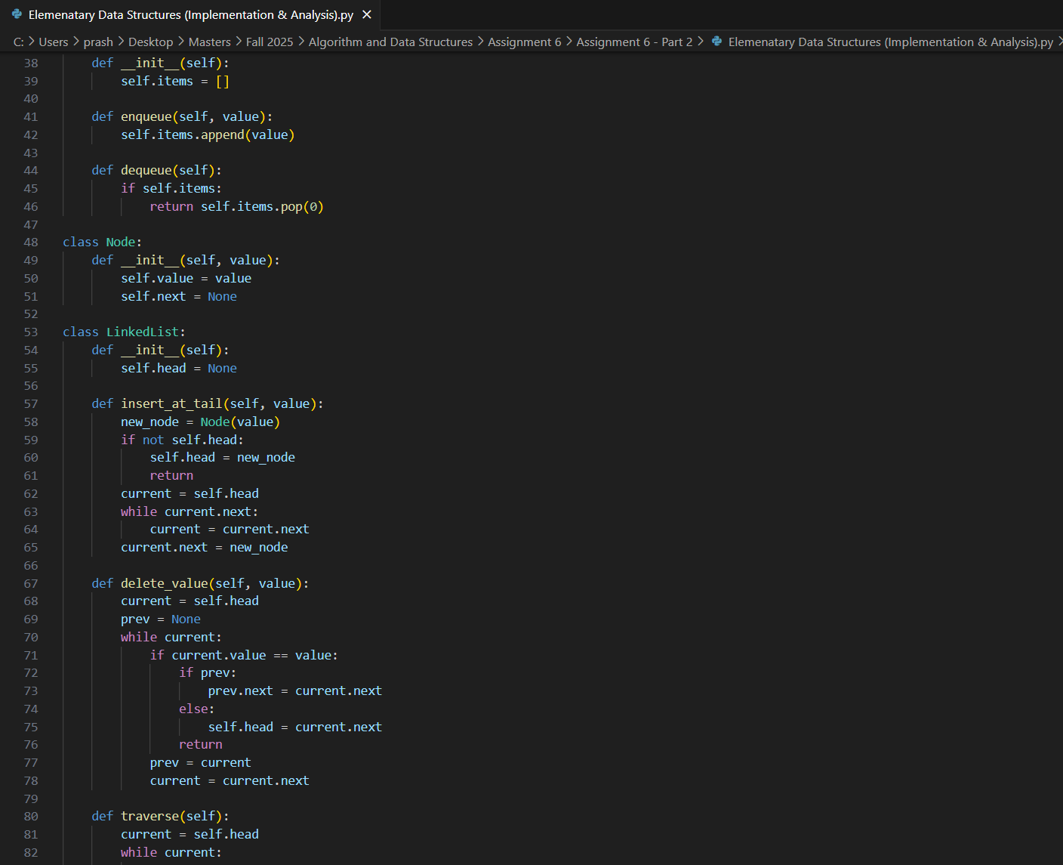
The below Python program implements five foundational data structures: arrays, matrices, stacks, queues, and singly linked lists. Each data structure is built from scratch without relying on Python’s built-in data structures, demonstrating fundamental operations. Arrays support insertion, deletion, and access by index. Matrices extend arrays to two dimensions, enabling row and column manipulation. Stacks and queues are implemented using arrays, where stacks follow a last-in-first-out (LIFO) principle and queues follow a first-in-first-out (FIFO) principle. The singly linked list is built using nodes connected by pointers, supporting dynamic insertion and deletion at both the head and tail.

Performance Analysis
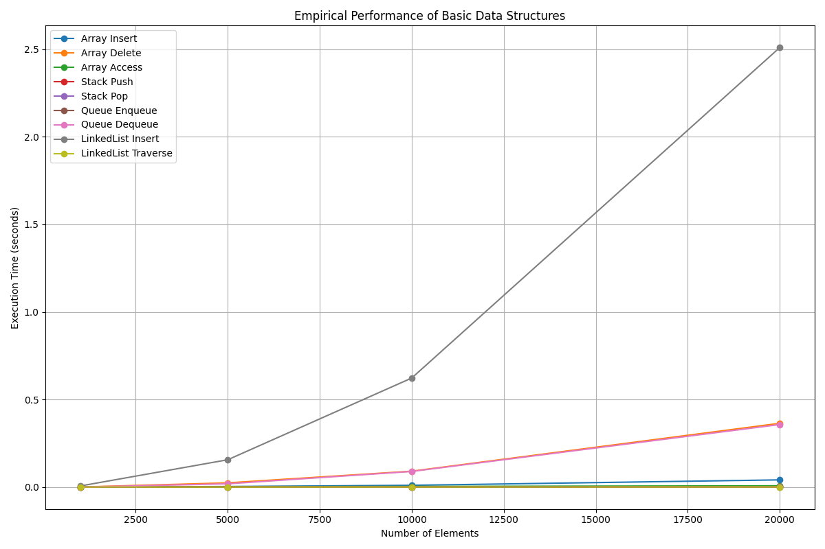
Arrays: Accessing elements in an array is O(1) due to direct indexing. Insertion and deletion are O(n) in the worst case because elements may need to be shifted to maintain order.
Matrices: Operations on a fixed-size matrix take O(1) for single element access or modification. Iterating through the matrix is O(n × m), where n and m are the number of rows and columns.
Stacks and Queues (Array-based): Push, pop, enqueue, and dequeue operations are O(1) on average for stacks and O(n) for queue dequeue (since elements are shifted). Using a linked list for queues can reduce dequeue time to O(1).
Linked Lists: Insertion and deletion at the head are O(1), while insertion/deletion at the tail or arbitrary positions is O(n) due to traversal. Access by index requires O(n) time, making linked lists less efficient than arrays for random access.
The trade-offs highlight that arrays excel at fast random access but incur shifting costs for insertion/deletion, whereas linked lists provide dynamic memory usage with efficient head operations but slower indexed access.
Practical Applications
Arrays and Matrices are widely used in applications requiring fast indexing and multi-dimensional storage, such as image processing, scientific computing, and game development. Stacks are ideal for expression evaluation, backtracking algorithms, and undo functionalities. Queues are applied in task scheduling, breadth-first search, and real-time event handling. Linked lists are suitable for scenarios requiring frequent insertion and deletion, such as memory management, dynamic lists, and adjacency lists in graph representations.
Choosing the right data structure depends on the use case: arrays are preferred for speed in indexed access and compact memory storage, whereas linked lists are useful for dynamic, frequently changing datasets. Stacks and queues can be implemented with either arrays or linked lists depending on whether memory overhead or operation speed is more critical.

References
Cormen, T. H., Leiserson, C. E., Rivest, R. L., & Stein, C. (2009). Introduction to algorithms (3rd ed.). MIT Press.
Goodrich, M. T., Tamassia, R., & Goldwasser, M. H. (2014). Data structures and algorithms in Python. Wiley.
Knuth, D. E. (1997). The art of computer programming, Volume 1: Fundamental algorithms (3rd ed.). Addison-Wesley.
Weiss, M. A. (2013). Data structures and algorithm analysis in Python (2nd ed.). Pearson.
Python Software Foundation. (2025). Python documentation: Data structures. https://docs.python.org/3/tutorial/datastructures.html
GeeksforGeeks. (2025). Arrays, linked lists, stacks, and queues in Python. https://www.geeksforgeeks.org

